**CYBER SECURITY WEEK 4 ASSIGNMENT**

**OLANREWAJU ADESINA FE/23/10260344**

**Assignment**: Your organization has 5 departments, namely HR, Finance, Training, Operations and Security. Create file1 and file2 in the HR directory and then move file2 to the Training department while you copy file1 and file2 to the remaining departments

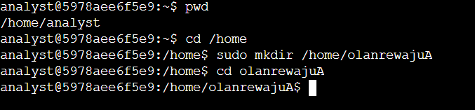

1) The lab starts with the user account called analyst and the directory /home/analyst.

First I need to identify my present working directory(pwd) which is /home/analyst, then I navigated to the home directory using the command cd /home. Then I created a new directory in my name called olanrewajuA using the command sudo mkdir /home/olanrewajuA. After creating the new directory, I navigated to it from the home directory using the command cd olanrewajuA

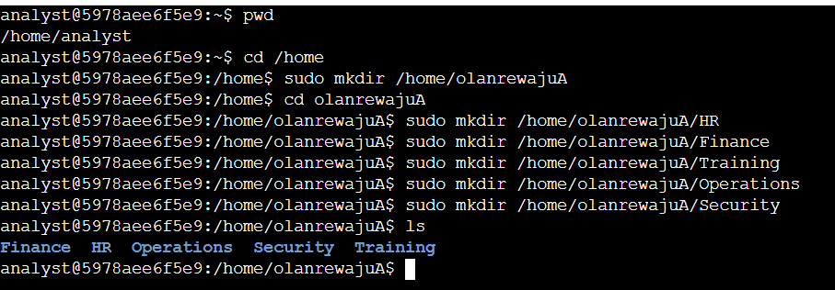

2) Next, I created my organizations 5 departments as a sub-directory of the olanrewajuA directory. The names of the 5 newly created directories are HR, Finance, Training, Operations and Security. The following commands were used to create the directories

Sudo mkdir /home/olanrewajuA/HR

Sudo mkdir /home/olanrewajuA/Finance

Sudo mkdir /home/olanrewajuA/Training

Sudo mkdir /home/olanrewajuA/Operations

Sudo mkdir /home/olanrewajuA/Security

To confirm the directories have been created, I used the ls command to display sub-directories in olanrewajuA

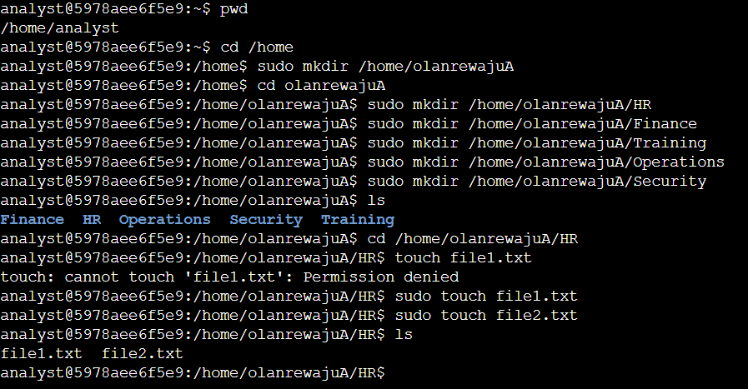

3) To create file1 in the HR directory, I navigated to the HR directory using cd /home/olanrewajuA/HR, then I created the file1 using sudo touch file1.txt command. I repeated the same process to create file2 in the HR directory using sudo touch file2.txt command. To confirm both files have been created I listed the files in the HR directory using the command ls while in the HR directory.

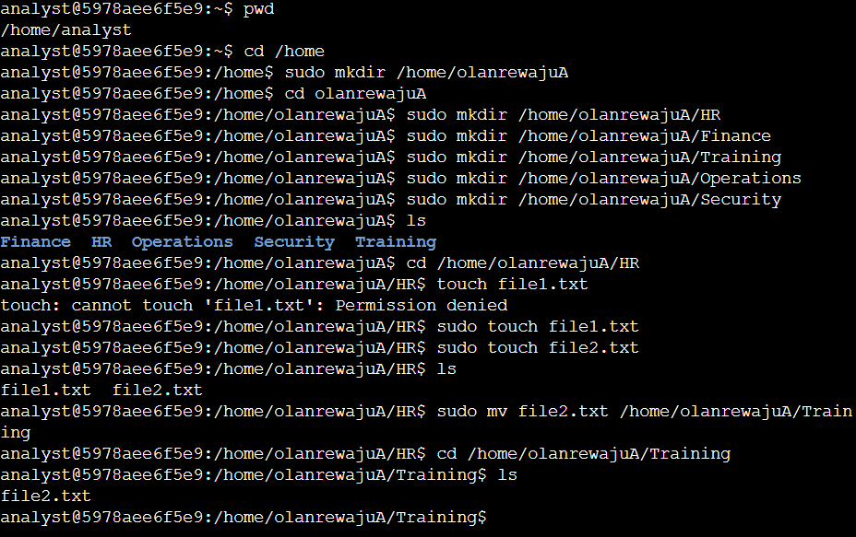

4) To move file2 to the Training department, I used the command sudo mv file2.txt /home/olanrewajuA/Training then I navigated to the Training directory using cd /home/olanrewajuA/Training command and ls command to list and confirm the file2.txt has been moved to the Training directory.

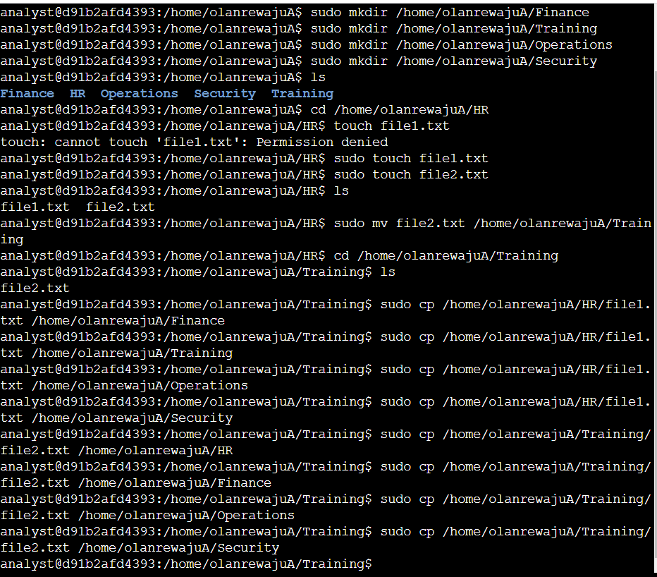

5) To copy file1 from the HR department to the remaining departments, I used the commands below

sudo cp /home/olanrewajuA/HR/file1.txt /home/olanrewajuA/Finance

sudo cp /home/olanrewajuA/HR/file1.txt /home/olanrewajuA/Training

sudo cp /home/olanrewajuA/HR/file1.txt /home/olanrewajuA/Operations

sudo cp /home/olanrewajuA/HR/file1.txt /home/olanrewajuA/Security

To copy file2 from the Training department to the remaining departments, I used the commands below

sudo cp /home/olanrewajuA/Training/file2.txt /home/olanrewajuA/HR

sudo cp /home/olanrewajuA/Training/file2.txt /home/olanrewajuA/Finance

sudo cp /home/olanrewajuA/Training/file2.txt /home/olanrewajuA/Operations

sudo cp /home/olanrewajuA/Training/file2.txt /home/olanrewajuA/Security

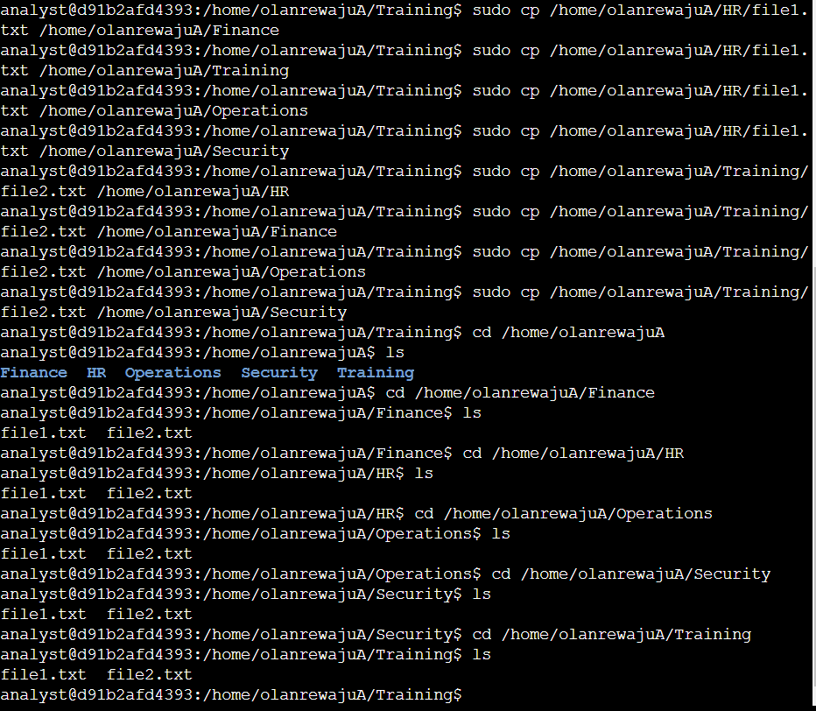

6) Finally, to confirm that both file1 and file 2 are in all departments, I navigated to the /home/olanrewajuA directory using cd /home/olanrewajuA, listed all departments with the ls command. I also listed every file in each directory/department and confirmed file1.txt and file2.txt in every department.